Suman Khadka
Khsum20@gmail.com
Decarbonizing Transportation in Durham
EMISSIONS TRENDS, STRATEGY, AND RECOMMENDATIONS

Executive Summary
Transportation is one of the largest sources of greenhouse gas (GHG) emissions in the Raleigh-Durham region, contributing an estimated 42% of the region's total emissions (2022 baseline), above the national average of roughly 29%. Addressing transportation emissions is therefore critical to achieving Durham's climate goals.
The City of Durham has committed to 100% renewable energy and carbon neutrality community-wide by 2050, with an interim target of carbon neutrality for city government operations by 2040 (City of Durham, 2021). Meeting these goals requires distinct near-term and long-term strategies for the transportation sector. In the near term, drop-in alternative fuels such as e-fuels and biofuels can deliver meaningful reductions without requiring changes to existing vehicle or fueling infrastructure. Over the longer term, electrification powered by renewable energy — paired with alternative fuels for long-haul and hard-to-abate freight — should become the primary pathway.
To decarbonize the transportation sector, this report recommends: expanding charging infrastructure in public places and residential areas; ensuring affordable, fossil-free electricity for charging; and supporting hard-to-abate sector in adopting alternative fuels alongside electrification.

Introduction & Context
Anthropogenic emissions are the major driver of global warming. To prevent irreversible damage, global average temperature rise must be kept well below 2°C above pre-industrial levels, according to the Paris Agreement. The consequences of climate change are already visible worldwide — floods, droughts, wildfires, and heat waves have intensified in frequency and severity. Limiting warming to this threshold is therefore critical, and every country has set its own climate and renewable energy targets based on available resources and capacity.
The City of Durham has committed to carbon neutrality for city government operations by 2040, and to 100% renewable energy and carbon neutrality community-wide by 2050 (City of Durham, 2021). Achieving these targets requires carefully orchestrating multiple technological pathways so that the resulting energy system is not only renewable, but also self-sufficient, reliable, resilient, and just. Stakeholders negatively affected by this transition must also be considered, with appropriate rehabilitation plans put in place.

The fleet-composition analysis in following section models vehicles registered to Durham County residents, using EPA-standard per-vehicle emission rates. Because it excludes freight trucks and through-traffic, it understates total transportation emissions and should be read as an indicator of local fleet trends and EV adoption — not as a substitute for the county-wide totals.

Current State of Transportation Emissions

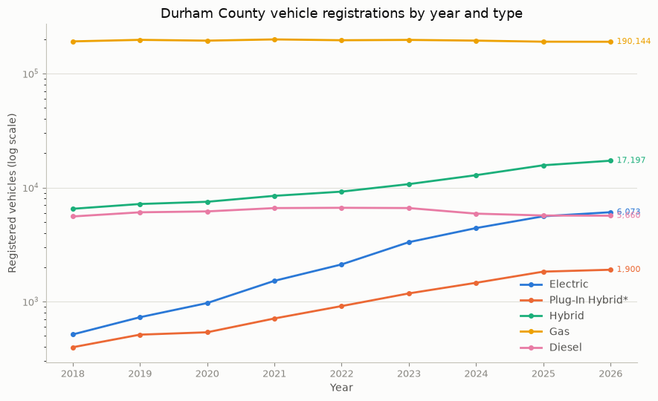
Figure 1. Vehicle registration by year and type. (North Carolina Office of State Budget and Management, 2026).
Figure 1 illustrates the vehicle registration by year and type in Durham County from 2018 to 2026. Gas still dominates Durham's transportation fuel mix. However, the growth rates of electric vehicle tell that the transition is getting momentum. EVs have grown from near-zero to overtaking diesel in just 8 years, a ~12x increase since 2018, while gas registrations are essentially flat — meaning nearly all fleet growth is happening in the alternative-fuel categories, not gas. It is also evidence that consumer interest in EV is growing and with the right policies and infrastructure this can be further increased.
Total fleet emissions in Durham County (illustrated in figure 2) have remained essentially flat at roughly 0.92–0.97 million metric tons CO2 per year across all nine years shown, despite real growth in EV and hybrid registrations, indicating that transportation decarbonization has made no measurable progress toward the city's 2050 carbon-neutrality target so far. Gas vehicles still account for over 90% of total emissions, and the scale gap remains stark. EV adoption hasn't reached the volume needed to bend the total downward. This points to several compounding challenges: current incentives and policy haven't yet shifted fleet composition fast enough to show up in aggregate emissions; EVs aren't truly zero-emission but are capped by the grid's carbon intensity (593.4 lbs/MWh) (EPA, 2026). Vehicles typically remain in service 10–15+ years — means today's registration trends will take considerable time to displace the existing gas fleet, making the 2050 deadline closer than the current trajectory suggests.

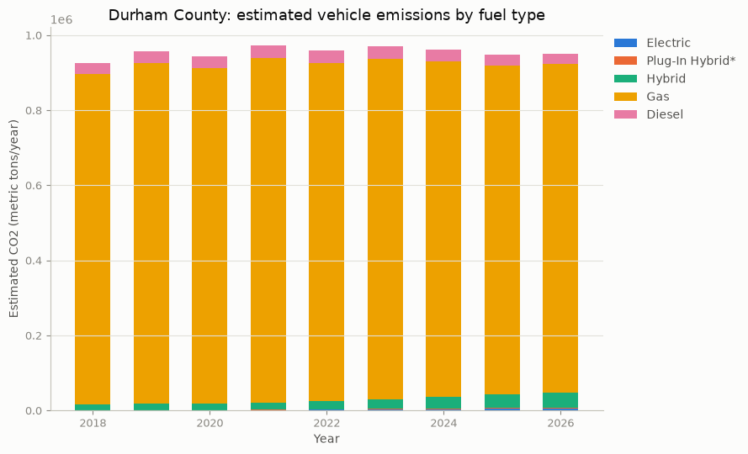
Figure 2. Durham county transportation emission

Decarbonization Strategy
Figure 3 presents decarbonization framework for Durham’s transportation sector. Decarbonizing Durham's transportation sector requires multiple pathways pursued in parallel rather than a single sequential fix. Newly registered vehicles typically remain in service for 10–15 years or more, so retiring them before the end of their useful life to replace them with electric vehicles is neither economically nor environmentally logical — it discards the embedded manufacturing emissions of a functioning vehicle while adding the emissions cost of building a new one.
Alternative fuels such as e-fuels and biofuels offer a more practical route for this existing fleet: because they are compatible with current vehicles and fueling infrastructure, they can reduce emissions immediately without requiring premature vehicle turnover. Electrification, meanwhile, is the appropriate pathway for new vehicle purchases and natural fleet replacement, paired with renewable-sourced electricity to ensure the full climate benefit is realized rather than blunted by a fossil-heavy grid. Freight and long-haul transportation remain the most difficult segment regardless of pathway — battery weight, range, and charging infrastructure constraints limit electrification's feasibility today, making alternative fuels the more realistic option for this category in the near term. These pathways are complementary rather than competing alternative fuels decarbonize the fleet already on the road, while electrification and clean electricity decarbonize the fleet still to come.

Figure 3. Decarbonization framework for Durham’s transportation sector. (Author's analysis, 2026)

Recommendations
To accelerate transportation decarbonization, this report recommends:
- Expand public charging infrastructure at retail centers, public lots, and residential areas.
- Tie charging programs to clean, fossil-free electricity, through a requirement or incentive, so the emissions benefit is not undermined by grid intensity.
- Require or encourage affordable resident charging access from housing providers and landlords, since a lack of at-home charging remains a common barrier to EV adoption for renters.
- Support hard- to-electrify transportation sectors in adopting alternative fuels alongside electrification through targeted grants or tax credits, reflecting the blended-pathway approach outlined above.
Implementing these recommendations requires coordinated action across multiple stakeholders:
- Durham City Council and the Department of Transportation — set policy and funding priorities.
- Duke Energy — expand grid capacity and clean generation.
- Private landlords — enable resident charging access.
- Freight and logistics companies — adopt alternative fuels within their own fleets.

Conclusion
Transportation remains one of the largest sources of greenhouse gas emissions in the Raleigh-Durham region, contributing an estimated 42% of total regional emissions, and the Durham County fleet analysis in this report shows emissions have stayed essentially flat despite growing EV and hybrid registrations. Meeting the City of Durham's commitments — carbon neutrality for city operations by 2040 and 100% renewable energy with community-wide carbon neutrality by 2050 — requires pursuing alternative fuels, electrification, and clean electricity as parallel pathways rather than waiting on a single mature technology, alongside support for freight and logistics operators where full electrification remains furthest out of reach. The recommendations outlined in this report — expanding charging infrastructure, requiring clean electricity for charging programs, enabling residents charging access, supporting freight fuel transitions, and continuing transit electrification and mode-shift investment — provide a path toward closing the gap between Durham's current emissions trajectory and the City's 2050 climate commitments.

Bibliography
City of Durham. (2021). Carbon neutrality & renewable energy action plan. Retrieved September 20, 2026, from https://www.durhamnc.gov/CivicAlerts.aspx?AID=2975&ARC=4162.
North Carolina Office of State Budget and Management. (2026). Vehicle registration [Data set]. LINC. Retrieved September 20, 2026, from https://linc.osbm.nc.gov/explore/assets/vehicle-registration/view/
U.S. Environmental Protection Agency. (2026a). Greenhouse gas emissions from a typical passenger vehicle. Retrieved September 20, 2026, from https://www.epa.gov/greenvehicles/greenhouse-gas-emissions-typical-passenger-vehicle
U.S. Environmental Protection Agency. (2026b). Power Profiler. Retrieved September 20, 2026, from https://www.epa.gov/egrid/power-profiler#/

Appendix 1. Vehicle registration by year and fuel type. (North Carolina Office of State Budget and Management, 2026)
Year | Electric | Plug-In Hybrid | Hybrid | Gas | Diesel
2018 | 514.0 | 397.0 | 6510.0 | 191582.0 | 5576.0
2019 | 728.0 | 512.0 | 7171.0 | 197604.0 | 6063.0
2020 | 969.0 | 537.0 | 7500.0 | 194454.0 | 6176.0
2021 | 1519.0 | 710.0 | 8458.0 | 199405.0 | 6604.0
2022 | 2116.0 | 912.0 | 9209.0 | 196092.0 | 6641.0
2023 | 3317.0 | 1178.0 | 10717.0 | 197409.0 | 6608.0
2024 | 4410.0 | 1460.0 | 12840.0 | 194581.0 | 5903.0
2025 | 5596.0 | 1829.0 | 15687.0 | 190392.0 | 5685.0
2026 | 6073.0 | 1900.0 | 17197.0 | 190144.0 | 5660.0

Appendix 2. Emission calculation, data used and assumptions. (U.S. Environmental Protection Agency, 2026a); U.S. Environmental Protection Agency, 2026b)
Vehicle Type | Number of Vehicles | Emission Factor  (t CO2/veh/yr) | Annual Mileage  (mi/yr) | Estimated Emissions  (t CO2/yr)
Electric | 6,073 | 0.929 | 11,500 | 5,642
Plug-In Hybrid* | 1,900 | 1.400 | 11,500 | 2,660
Hybrid | 17,197 | 2.300 | 11,500 | 39,553
Gas | 190,144 | 4.600 | 11,500 | 874,662
Diesel | 5,660 | 5.100 | 11,500 | 28,866
Total | 220,974 |  |  | 951,383

